Step 1: Setup your machine with Git Configuration

To create a new repository, signup with GitLab and register your credentials
Login to GitLab and create a “GitDemo” project

- To check if Git client is installed properly

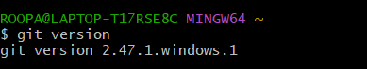

If output shows Git with its version information that indicates, that Git Client installs properly.

- To configure user level configuration of user ID and email ID execute

- To check if the configuration is properly set, execute the following command.

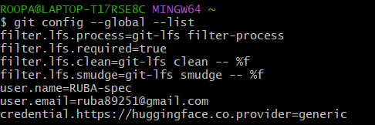

Step 2: Integrate notepad++.exe to Git and make it a default editor

- To check, if notepad++.exe execute from git bash


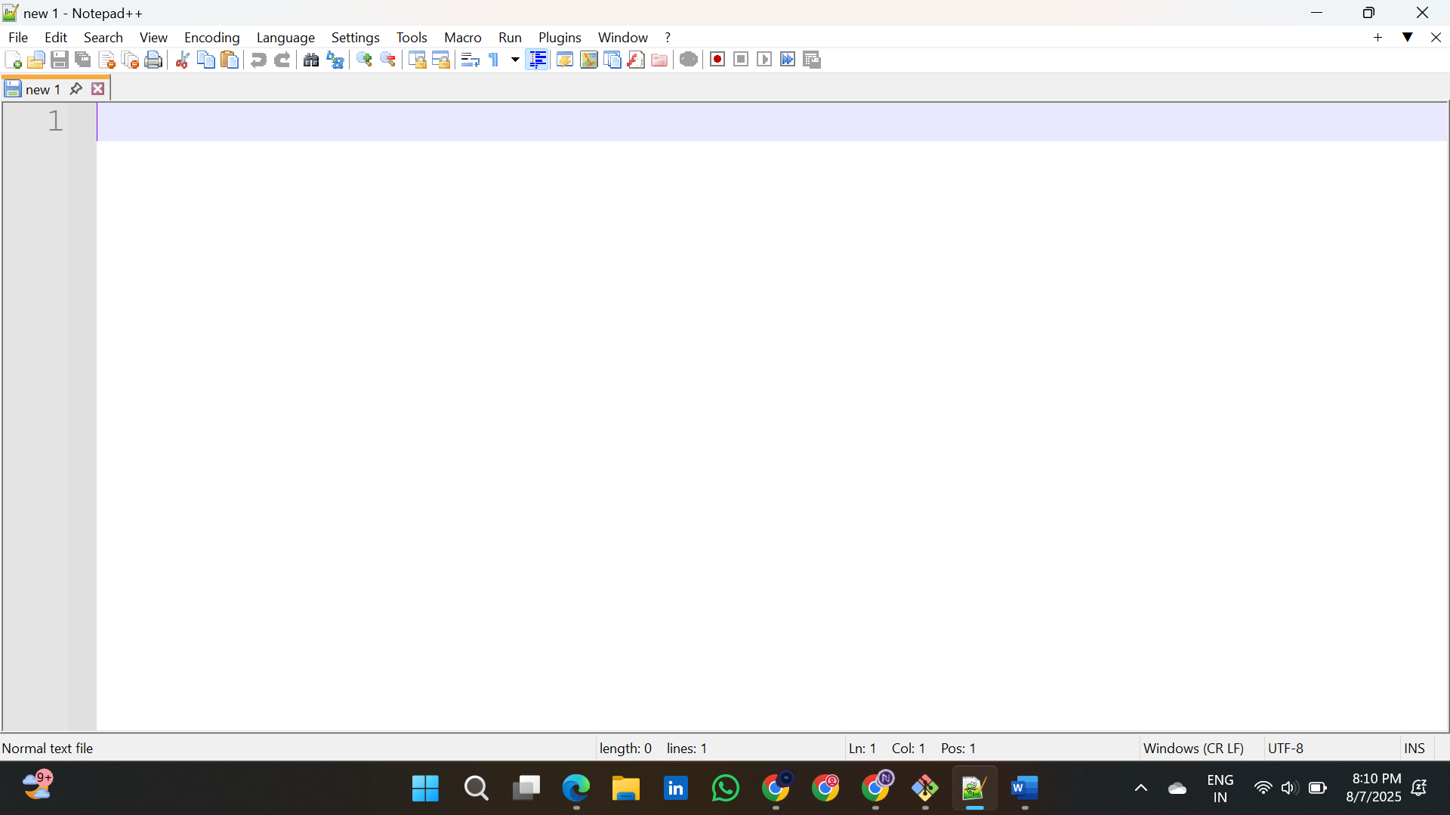

- To create an alias command for notepad++.exe, execute

It will open notepad++ from bash shell, and create a user profile by adding the line in notepad++

- To configure the editor, execute the command

- To verify if notepad++ is the default editor, execute the command
Here ‘-e’ option implies editor

It will show the entire global configuration as shown below,
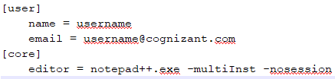

Step 3: Add a file to source code repository

- Open Git bash shell and create a new project “GitDemo” by executing the command

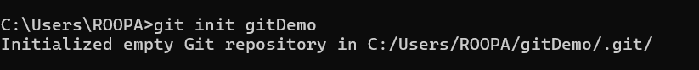
2.To initialize git repository named “GitDemo”
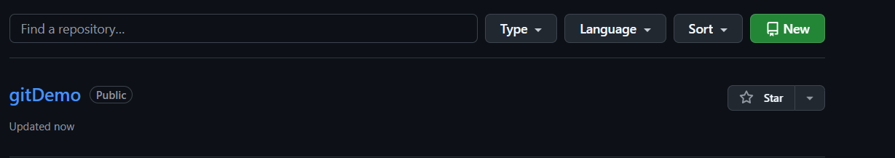

- To create a file “welcome.txt” and add content to the file

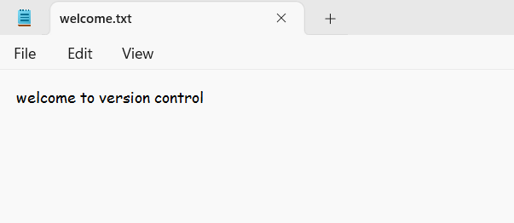

- To verify the content, execute the command

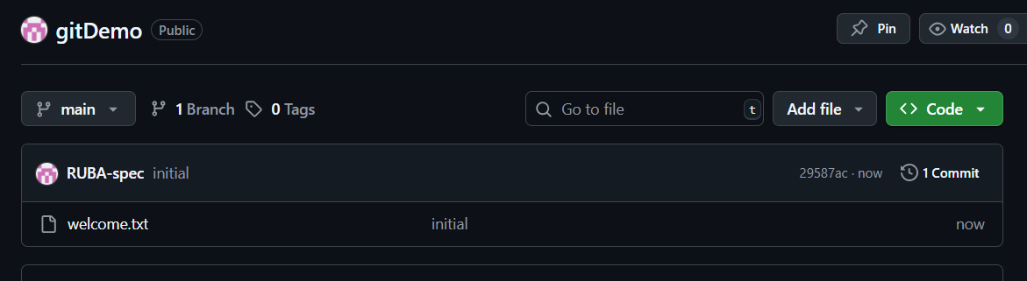

- Check the status by executing
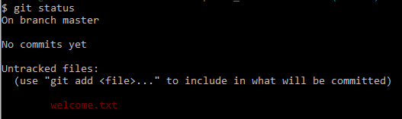

Now the file “welcome.txt” is available in Git “working directory”

- To make the file to be tracked by Git repository, execute the command
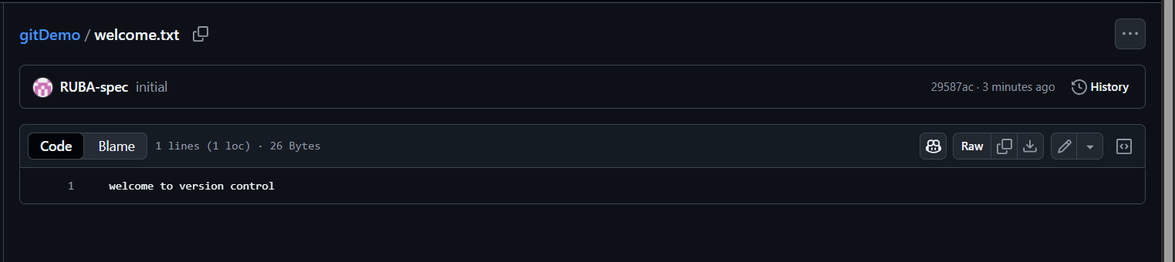

- Check the status
